Project Report

Product Name | Applied Degree in Software Engineering
Qualification Name (NICF) | Applied Degree in Software Engineering
Product Name | Design, develop and test the Community portal website
Module Name (NICF) | NICF-Application Implementation

Student Name |  | Assessor name
Viddy Virstandi P.A.P |  | Arvinder Kaur
Date issued | Completion date |  | Submitted on
20-08-2022 | 23-08-2022 |  | 23-08-2022
Project title | Design, develop and test the Community portal website

Learner declaration
I certify that the work submitted for this assignment is my own and research sources are fully acknowledged.

Student signature : Viddy Virstandi P.A.P Date : 23-08-2022

AIM Project report
Content
- Project Background
- Project Objective
- Project Scope
- Tools and Platform
- Task 1
- Task 2
- Task 3
- Task 4
- Task 5
- Task 6
- Task 7
- Project Background
ABC Jobs Pte Ltd as a website developer to develop a community portal for Software Developers.

Project Objectives
The objective of the Test is to verify that the functionality of Community Portal works according to the requirements.

- Project Scope
2.1 Featured to be Tested
- Login
- Registration
- Forgot password
- View profile
- Update profile
- Search people

2.2 Feature Not to be Tested
- Job / Thread posting
- Messaging

2.3 Deliverables
•Briefly explain different types of testing which you will undertake
•Test Schedule Document
•Phase test plan
•Execute test scripts and verify the results
•Prepare a Project Report as per pre-defined template
•Prepare a Project Presentation as per pre-defined template
•Prepare a Testing Document

- Tools and Platform
- ProjectLibre
- Mc. Word
- Mc. PowerPoint

- Task 1 : Project Requirement Specifications (SRS document)
Task Statement : Write a brief requirement specification for the Report System

- Functional Requirements
No | Requirements | Web Page / Process | Field detail
1 | Users can register their data on the register page | Registration | Logo, text fields, hyperlink, button, copyright
2 | Users can login on the login page | Login | Logo, text fields, hyperlink, button, copyright
3 | Users can input their email on the Forget Password page | Forget Password | Logo, text fields, hyperlink, button, copyright
4 | Users can view their profile on the profile page | View Profile | Logo, text fields, hyperlink, button, copyright
5 | Users can update their profile on the update profile page | Update Profile | Logo, text fields, hyperlink, button, copyright
6 | Users can search other user on the search profile page | Search Profile | Logo, text fields, hyperlink, button, copyright

- Non-Functional Requirements
No | Requirements | Purpose
1 | Performance | Identify and eliminate the performance bottleneck in the software application
2 | Availability | To collect failure events and repair times
3 | Security aspects | To find and assess possible vulnerabilities in a system
4 | Database backup | To create a copy of data

- Technical requirements
Hardware
Processor : Intel Core or Xeon 3GHz (or Dual Core 2GHz) or equal AMD CPU.
Memory : 4 GB (6 GB recommended).
Graphic Accelerators : nVidia or ATI with support of OpenGL 1.5 or higher.

Software
- ProjectLibre
- MySql Workbench 8.0
- Angular
- Visual Studio Code
- MySql
- Chrome
- Firefox

- Task 2 : SDLC
Task Statement : Justify the chosen SDLC methodology with pro and cons

Waterfall Model
It’s a sequential model of SDLC. In this model, the software development activity is divided into different phases and each phase consist of a series of task and has different objectives. It is a mandatory for a phase to be completed before the next phase start.

- Requirement & Gathering Analysis
  - Capturing all requirements
      - Interview the clients
      - Conduct survey to stakeholders
      - Research similar product

  - Analysis the requirements
Brainstorming with team member to understand the requirement

  - Documenting the requirements
      - Develop the project Initiation document

      - Prepare the Project Plant document
        - Create work breakdown structure and work package
        - Estimation time and cost
        - Resources management
        - Project scheduling
        - Etc.

      - Create Quality Plan and Feasibility Test plan
      - Create Project Risk Management Plan Document
      - Document the Software Requirement Specification
      - Use case documentation
      - Requirement Traceability Matrix document
  - Do the Feasibility Test
  - Document Revision
      - Revised the test plan document
      - Revised the Initiation and Project plant document until meet the agreement with the stakeholders before sign the contract
  - Sign off to all Stakeholders of the Project Initiation document and the Project Plant document

- System Design
  - As per the Requirement, create the design
      - Design the business process
      - Create Class diagram, activity diagram, and use case diagram
      - Building the system architecture
      - Designing the UI / UX of the software
      - Create prototype of the software
      - Develop usability test plant
  - Capture the hardware and software requirement
  - Document the design
      - Document the system design
      - Report the design software document
      - Create user manual
      - Create maintenance manual
      - Prepare training plan
  - Conduct Usability Testing
  - Document Revision
      - Revised requirement traceability matrix
      - Revised test plant document
      - Revised the system architecture
      - Revised the UI / UX

- Implementation
- Prepare the code guideline documentation
- As per the design develop the software programs / code
- Build all the functionalities / feature as per the requirement:
        - Registration
        - Login and Logout
        - Forget password
        - Homepage
        - See and update own profile
        - Search and see other profile
        - Administration user data
        - Etc.
- Integrate the code for next phase
- Documenting the software program
- Create software development document
- Create integrate document
- Develop test case specification document
- Conduct Unit Testing for each component
- Revise the code and the documentation

- Testing
- Capture the test case document to perform testing
- Perform all the testing as per the documentation
- Perform Functional testing (Integration testing, acceptance testing, etc.)
- Perform Non-Functional testing (load testing, performance testing, etc.)
- Track the progress on testing through the traceability matrix documentation
- Gather and Analysis the test result as per meet the requirement
- Report all the testing activities and their result

- Deployment
- Prepare test case documentation for Beta testing
- Create user manual if needed
- Checking up
- Make sure the environment is ready
- Make sure there are no severe defect open
- Make sure the test exit criteria are met
- Deploy the application in the respective environment
- Testing up after deployment
- Perform sanity check in the environment
- Running the Beta testing
- Documenting
- Report results of the Beta Testing
- Create version control document
- Create post implementation review report
- Develop any change request documentation

- Maintenance
        - Checking up
- Make sure the application is up and running in the respective environment
- Report any defect encounter by user
- Back up database
        - Fix the issued faced and updated code is deployed in the environment
        - Propose any enhancement to incorporate more feature
        - Update the environment with the latest feature
        - Documenting maintenance activities
- Document the new feature propose for to be implemented
- Issue tracking document
- Update version control document

Advantages of using Waterfall as the Model
- Easy to manage as each phase need to be complete on time and no overlaps schedule
- The entry and exit criteria are well defined as per the requirement are certain, it can proceed accordingly with quality
- Resulted will be well documented

Disadvantages of using Waterfall as the Model
- Difficult to go back and change
- Not a good model for complex and object-oriented programming
- Poor model for long and ongoing projects

- Task 3 : Project Plan
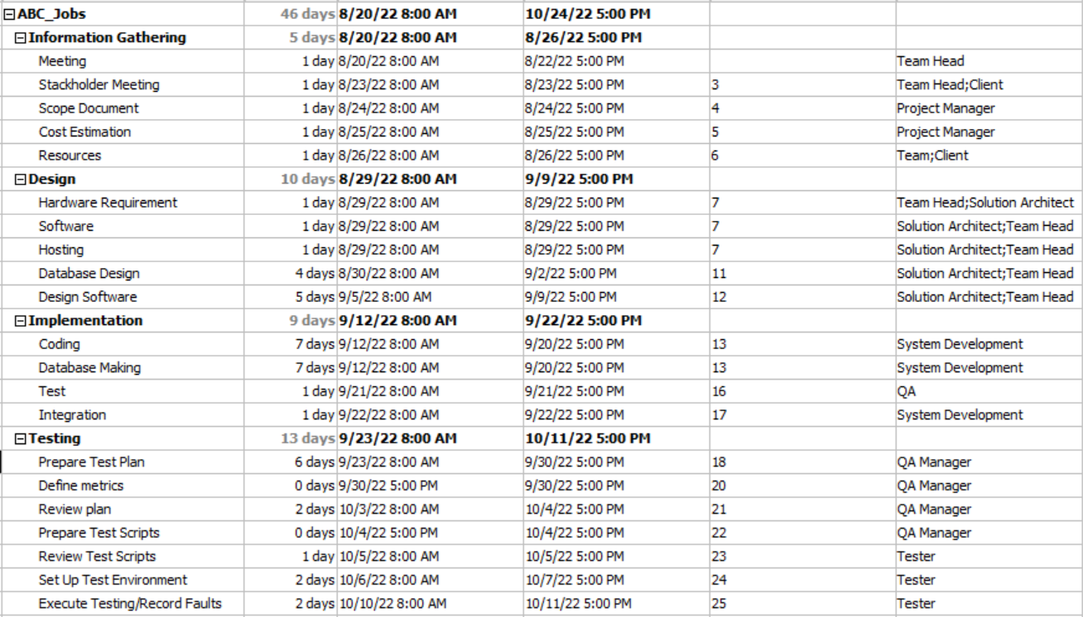
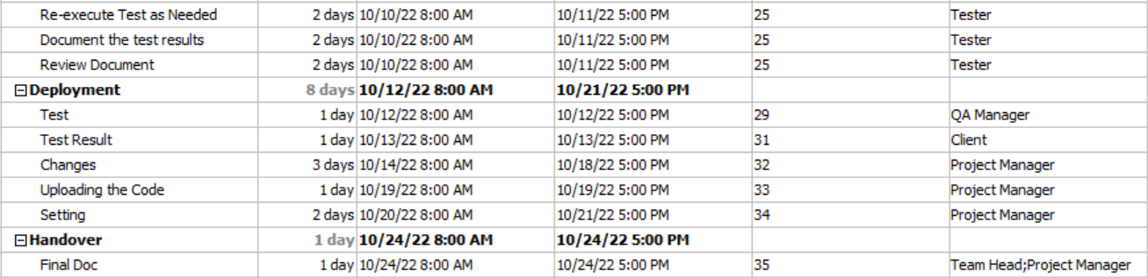
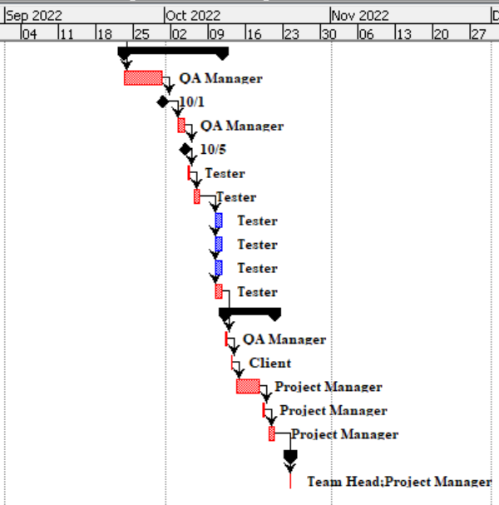
- Task 4 : Testing methods
Task Statement : Explain the benefits of 3 testing methods under functional and non-functional category

Functional Testing
- Unit testing : help fix bug in early development
- Integration testing : Test the automation of the combination of existing components
- System testing : Checking the program against specification

Non Functional Testing
- Performance testing : Knowing the performance of a system when faced various situation
- Security testing : Find system vulnerabilities that might result in information loss
- Usability testing : Knowing the user experience of product design

- Task 5 : Optimal Scheduling
Task Statement : Identify appropriate method to compute the testing schedule duration and prepare the test schedule

No | Feature | Weighing | Functional Point | Total points
1 | Login | 1 | 2 | 2
2 | Logout | 1 | 1 | 1
3 | Registration | 3 | 4 | 12
4 | Forgot password | 3 | 5 | 15
5 | View profile | 1 | 2 | 2
6 | Update profile | 3 | 4 | 12
7 | Search another user | 1 | 2 | 2
 | Total functional points |  |  | 46
 | Estimated Person hours /FP |  |  | 1
 | Total person hours |  |  | 46
 | Person hours / day (8 hours) |  |  | 5.75

Test Schedule :
Test Schedule ID : | TSCH01
Product ID / Name : | ABC Jobs Community Portal
Product Version or Build : | 0.0.1
Present Owner : | Viddy Virstandi P.A.P | Software Engineer
Created On : | 20-08-2022
Review On : | 21-08-2022
Review By : | Amir El-Amari | QA Manager
Review Comments : | Good
Current Version : | 1.0
Change Details :
Current Status : | Complete
Signing Off Authority : | Viddy Virstandi P.A.P | Software Engineer

- Task 6: Phase Test Plan
No | Task | Start | End | Resource
1 | Prepare Test Plan | 23-09-2022 | 30-09-2022 | Viddy Virstandi P.A.P
2 | Define metrics |  |  | Viddy Virstandi P.A.P
3 | Review plan | 03-10-2022 | 04-10-2022 | Viddy Virstandi P.A.P
4 | Prepare Test Scripts |  |  | Viddy Virstandi P.A.P
5 | Review Test Scripts | 05-10-2022 | 06-10-2022 | Viddy Virstandi P.A.P
6 | Set up Test Environment | 06-10-2022 | 07-10-2022 | Viddy Virstandi P.A.P
7 | Execute Testing/Record Faults | 10-10-2022 | 11-10-2022 | Viddy Virstandi P.A.P
8 | Re-execute Test as Needed | 10-10-2022 | 11-10-2022 | Viddy Virstandi P.A.P
9 | Document the test results | 10-10-2022 | 11-10-2022 | Viddy Virstandi P.A.P
10 | Review Document | 10-10-2022 | 11-10-2022 | Viddy Virstandi P.A.P

- Task 7 : UNIT and UAT Test Scripts
Task Statement : Prepare the test scripts with use case, scenario, test description, pre-conditions, test data, and expected output

Test Scenario :
Requirements | Test Scenario ID | Test Scenario | Number of test cases
Functional Testing | TS001-Unit testing | Ensure that user enters correct data in the registration page | 3
 | TS002-UAT testing | Check that a navigation menu is provided on each page and is consistent. | 3

Scenario 1 : Unit Testing
Test Scenario | Ensure that user enters correct data in the registration page
TS001
Test Cases | Unit Testing
TC001 | Check all the mandatory fields are entered
TC002 | Check the email-address validation working correctly
TC003 | Check post submission loading of thank you page

Test Cases :
Scenario ID | Test Case ID | Test Case | Preconditions | Test Step | Test Data | Expected Results | Actual Results | Pass / Fail
TS001 | TC001 | Test Case 1 | The user should have URL of website and opened a homepage of the abcjobs.com | - Type www.abcjobs.com.  - Click “Sign up” in website home page linked to registration page.  - Enter all the fields.  - Click submit. | Email : Ncull@email.com  Password : abcd1234  First Name : Viddy  Last Name : Purnama  Country : Indonesia  City : Jakarta  Company : Lithan | User should land to Registration Confirmation Page | As expected | Pass
 |  |  |  |  | Email : Ncull@email.com  Password : abcd1234  First Name : Viddy  Last Name : Purnama  Country :  City :  Company : Lithan | It will Display error message “Please enter country”  It will Display error message “Please enter city” | As expected | Pass
TS001 | TC002 | Test case 2 | The user should have URL of website and opened a homepage of the abcjobs.com | - Type www.abcjobs.com.  - Click “Log In” in website home page linked to registration page.  - Enter all the fields.  - Click submit. | Email : Ncull@email.com  Password : abcd1234 | User should land to Profile Page | As expected | Pass
 |  |  |  |  | Email : Ncull@emaol.com  Password : abcd1234 | It will Display error message “Please enter valid email” | As expected | Pass
TS001 | TC003 | Test Case 1 | The user should have URL of website and opened a homepage of the abcjobs.com | - Type www.abcjobs.com.  - Click “Sign up” in website home page linked to registration page.  - Enter all the fields.  - Click submit | Email : Ncull@email.com  Password : abcd1234  First Name : Viddy  Last Name : Purnama  Country : Indonesia  City : Jakarta  Company : Lithan | User should land to Registration Confirmation Page | As expected | Pass
 |  |  |  |  | Email : Ncull@email.com  Password : abcd1234  First Name : Viddy  Last Name : Purnama  Country :  City :  Company : Lithan | It will Display error message “Please enter country”  It will Display error message “Please enter city” | As expected | Pass

Scenario 2 : UAT Testing
Test Scenario | Check that a navigation menu is provided on each page and is consistent.
TS002
Test Cases | UAT Testing
UAT01 | Check each hyperlink menu is loading correct page
UAT02 | Log-in to community portal with the account that has been created
UAT03 | Reset the password

Scenario ID | Test Case ID | Test Case | Preconditions | Test Step | Test Data | Expected Results | Actual Results | Pass / Fail
TS002 | UATC01 | Check each hyperlink menu is loading the correct page | The website is configured to Browser by Apache Tomcat Server. | - Go to Browser  - Type www.abcjobs.com and enter.  - User will landing on Home Page | Click on Sign in link  Click on Login link | Loaded registration page  Loaded Login page | As expected | Pass
TS002 | UATC02 | Log-in to community portal with the account that has been created | The website is configured to Browser by Apache Tomcat Server. | - Go to Browser  - Type www.abcjobs.com and enter.  - User will landing on Home Page  - Click Log-in button | registered username and password | User will be redirect to user profile page | As expected | Pass
TS002 | UATC03 | Reset the password | The website is configured to Browser by Apache Tomcat Server. | - Go to Browser  - Type www.abcjobs.com and enter.  - User will landing on Home Page  - Click Log-in button  - Click Forget Password button | Registered email address | User will be redirect to Forget Password Confirmation page | As expected | Pass

